|  |  |  |  |  |  |  |  |
| --- | --- | --- | --- | --- | --- | --- | --- |
| **Name** | **Start** | **End** | **Duration** | **Time Since Last** | **Unemployment** | **GDP decline** | **Basic Notes** |
| COVID 19 | Feb 2020 | April 2020 | 2 months | 128 months | 14.7% | −19.2% | The outbreak of COVID-19 in November 2019 forced countries to institute travel restrictions and quarantines, closing many businesses. The initial outbreak expanded into the global pandemic in March 2020. |
| GFC | Dec 2007 | June 2009 | 18 months | 73 months | 10.0% | −5.1% | The subprime mortgage crisis led to the collapse of the United States housing bubble. Falling housing-related assets contributed to a global financial crisis, even as oil and food prices soared. |
| Dot Com  (9-11 attack) | Mar 2001 | Nov 2001 | 8 months | 120 months | 6.3% | −0.3% | The 1990s were the longest period of economic growth in American history up to that point. The collapse of the speculative dot-com bubble, a fall in business outlays and investments, and the September 11th attacks, brought the decade of growth to an end. |
| Early 1990s | July 1990 | Mar 1991 | 8 months | 92 months | 7.8% | −1.4% | Inflation began to increase and the Federal Reserve responded by raising interest rates from 1986 to 1989. This weakened but did not stop growth, but some combination of the subsequent 1990 oil price shock, the debt accumulation of the 1980s, and growing consumer pessimism combined with the weakened economy to produce a brief recession. |
| Early 1980s  Part 1 | July 1981 | Nov 1982 | 16 months | 12 months | 10.8% | −2.7% | The Iranian Revolution sharply increased the price of oil around the world in 1979, causing the 1979 energy crisis. This was caused by the new regime in power in Iran, which exported oil at inconsistent intervals and at a lower volume, forcing prices up. Tight monetary policy in the United States to control inflation led to another recession. |
| Early 1980s  Part 2 | Jan 1980 | July 1980 | 6 months | 58 months | 7.8% | −2.2% | The NBER considers a very short recession to have occurred in 1980, followed by a short period of growth and then a deep recession. Unemployment remained relatively elevated in between recessions. The recession began as the Federal Reserve, under Paul Volcker, raised interest rates dramatically to fight the inflation of the 1970s. |

How will Ukraine war affect stock market?

The Ukraine conflict may contribute to **increased short-term market volatility**. Disruption of Russian energy exports as a result of the conflict could temporarily contribute to rises in global energy and food prices

Will Russia Ukraine War affect stock market?

**Russia's Ukraine conflict, big inflation report will keep the stock market volatile in coming week**. Russia's invasion of Ukraine will continue to dominate markets in the week ahead, as oil and other commodities react to supply concerns

<https://www.bloomberg.com/news/articles/2022-03-02/no-corner-of-u-s-stock-market-left-untouched-by-war-in-ukraine>

From tech companies to banks to cruise-ship operators, virtually no corner of the U.S. stock market has been left untouched by Russia’s invasion of Ukraine.

The reasons are numerous. Oil prices have surged, boosting energy companies while threatening to fuel inflation already at a four-decade high. The conflict is casting uncertainty over the outlook for global economic growth even as [Federal Reserve](https://www.bloomberg.com/quote/13598Z:US) Chair Jerome Powell says the bank [is poised](https://www.bloomberg.com/news/articles/2022-03-02/powell-sees-fed-rate-liftoff-in-march-while-ukraine-fogs-outlook) to start raising interest rates this month. And volatility has surged as money-managers rush in and out of havens and industries like utilities and communication-service providers that are seen as relatively insulated from the latest risks.

**Wild Ride**

One of the most volatile segments of the market has been tech stocks, whose valuations are highly sensitive to higher interest rates and which serve as a gauge of risk-taking sentiment. The Nasdaq 100 Index’s average intraday swing over the last 30 days has climbed to nearly 3%, its highest since May 2020, early in the pandemic.

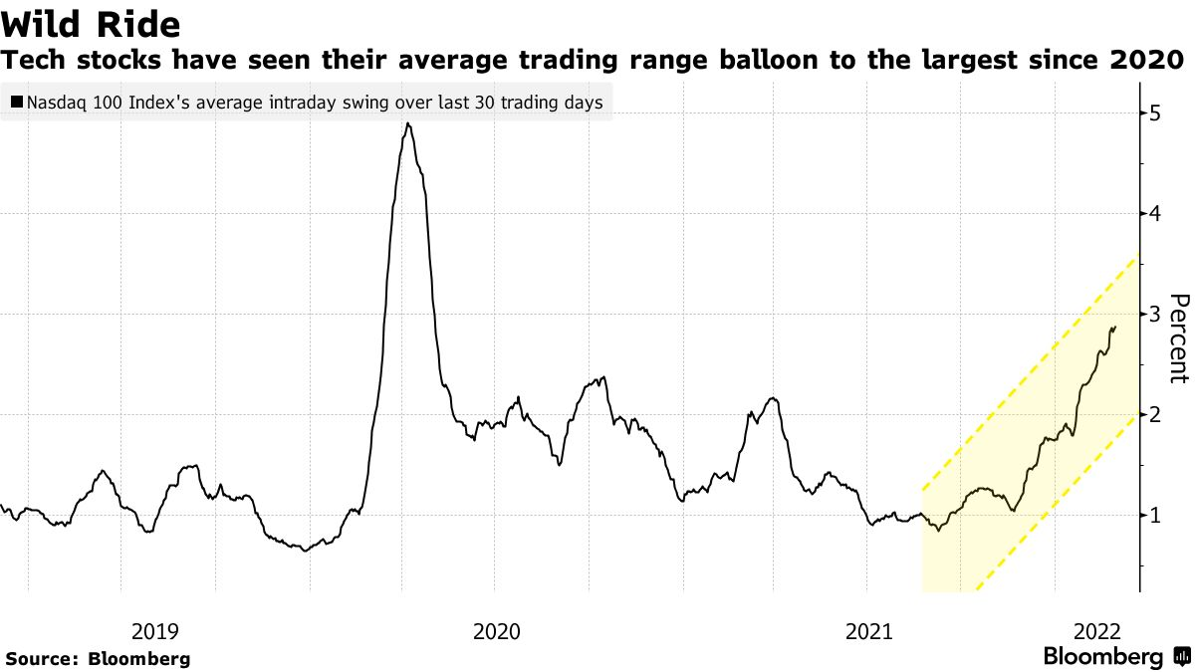

**Volatility Rises**

Even so, stocks are still down deeply this year as the war exaggerates already existing pressures. That briefly pushed the S&P 500 Index into correction territory -- or a drop of at least 10% from the peak -- for the first time since the coronavirus pandemic rocked markets in early 2020. The benchmark has since pared some of the drop and is down about 8.6% from the record high on Jan. 3. But that’s still the worst start to a year since 2009.

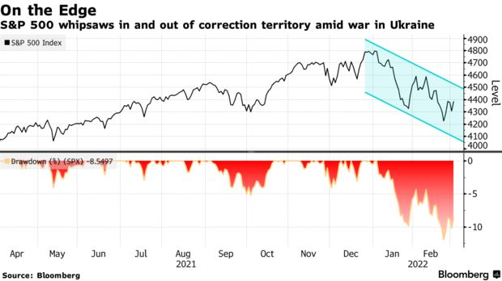

**The inverse occurs when GDP falls, leading to less spending by businesses and consumers, which drives the markets lower**; however, whether it's a bull market or bear market, the stock market has some level of impact, albeit indirectly, on GDP and the economy as a whole.

https://www.msci.com/documents/10199/a134c5d5-dca0-420d-875d-06adb948f578

If we further assume that: ♣ the share of company profits in the total economy remains constant; ♣ investors have a claim on a constant proportion of those profits; ♣ valuation ratios are constant; ♣ the country’s stock market only lists domestic companies; ♣ the country’s economy is closed, then we would expect an exact match between real price increase and real GDP growth. This theory is simple and makes intuitive sense. But is it true in practice? Several studies (Dimson et al. [2002], Ritter [2005]) have examined whether countries with higher long-run real GDP growth also had higher long-run real stock market return. The surprising result was contrary to expectations -- the correlation between stock returns and economic growth across countries can be negative! Our own analysis confirms this empirical finding: Exhibit 1 plots stock returns versus GDP growth for eight developed markets between 1958 and 2008 and also shows negative correlation. Note, however, that these tests are dependent on the starting and ending point of the period analyzed; by changing the period by only one year to 1958-2007, we get very different results (although the observed correlation in this example is still negative). For example, the annualized return for Belgium is changed from 1.7% to -0.5%.

**Things contribute to shareprice**

Fluctuations in the prices of financial assets in the stock market can sometimes seem to be inconsistent with what is happening in the rest of the economy – what’s sometimes referred to as the ‘real economy’.

For example, in 2020, US GDP fell by 3.5% – the largest contraction since the end of the Second World War ([Furman and Powell, 2021](https://www.piie.com/blogs/realtime-economic-issues-watch/what-us-gdp-data-tell-us-about-2020)). But the S&P 500 – a weighted index used to measure the US stock market – increased substantially during this period, more than recovering any temporary losses and ending the year 15% higher than its pre-pandemic level.

How do we explain this apparent disconnect?

<https://www.economicsobservatory.com/does-the-stock-market-reflect-the-economy>

The market value of a company should reflect how much cash investors believe the firm will make in the future. If changes in the broader economy are likely to affect company performance, then this should lead to changes in share prices. But it is important to emphasise that investors will consider not only what is happening now, but also what is likely to occur in the future.

Research has shown that a considerable proportion of the variation in share prices can be explained by key economic variables such as industrial production, inflation and interest rates, as well as changes in the dividends that companies pay to shareholders (Cutler et al, 1988). The evidence suggests that expectations about future changes in the economy play an important role in current pricing, although there may be some feedback effects involved, as changes in the stock market may actually cause changes in the wider economy.

But it has been has argued that share prices fluctuate more than they should – they exhibit ‘excess volatility’ (Shiller, 1981). What this means is that asset prices fluctuate more than is justified by changes to the fundamental characteristics of the underlying companies, which suggests that share prices may not always predict accurately what will happen in the future.

Prices are also affected by changes in the interest rate that is used to ‘discount’ future cash flows (Cochrane, 2011). Again, this means that prices may not necessarily reflect only predictions about company growth.

Gross domestic product (GDP), the featured measure of U.S. output, is the market value of the goods and services produced by labor and property located in the United States.For more information, see the Guide to the National Income and Product Accounts of the United States (NIPA) and the Bureau of Economic Analysis.

<https://www.rbcgam.com/en/ca/learn-plan/investment-basics/whats-the-relationship-between-the-stock-market-and-the-economy/detail>

<https://www.macrotrends.net/2526/sp-500-historical-annual-returns>

# https://www.macrotrends.net/2526/sp-500-historical-annual-returns

# S&P 500 Historical Annual Returns

<https://fred.stlouisfed.org/graph/?g=oCZ>

**S&P 500 / Gross Domestic Product**

<https://advisor.visualcapitalist.com/wall-street-vs-main-street-the-stock-market-is-not-the-economy/>

## GDP Growth and S&P 500 Returns

Here’s how annual GDP growth and [S&P 500 Index](https://advisor.visualcapitalist.com/sp-500-sectors-and-industries/) returns stack up from 1980 to the second quarter of 2021. Both metrics are net of inflation.

| **Year** | **Real GDP Growth** | **Real S&P 500 Returns** |
| --- | --- | --- |
| 1980 | -0.3% | 13.9% |
| 1981 | 2.5% | -18.3% |
| 1982 | -1.8% | 10.8% |
| 1983 | 4.6% | 13.4% |
| 1984 | 7.2% | -2.5% |
| 1985 | 4.2% | 23.0% |
| 1986 | 3.5% | 12.9% |
| 1987 | 3.5% | -2.2% |
| 1988 | 4.2% | 7.9% |
| 1989 | 3.7% | 22.4% |

https://advisor.visualcapitalist.com/wall-street-vs-main-street-the-stock-market-is-not-the-economy/